Deliverable #1 (2 Marks) due week 10 for professor review and feedback-Rohaan- Hoang Giang
Select two entity classes from deliverable #3 “Part B” and develop two state diagrams. The classes should have a dynamic nature within the scope of your project. Add the state diagrams to Appendix E of your SRS document.
Refer to unit 07 topic 7.2 chapter 8 & Appendix #1 of your textbook for further info about state diagrams.
Click on the following link for details on how to draw state diagrams using Microsoft Visio:
Visio state diagram

Entity classes 1: Modify Banking Info

Entity classes 2: Upload Lyrics.
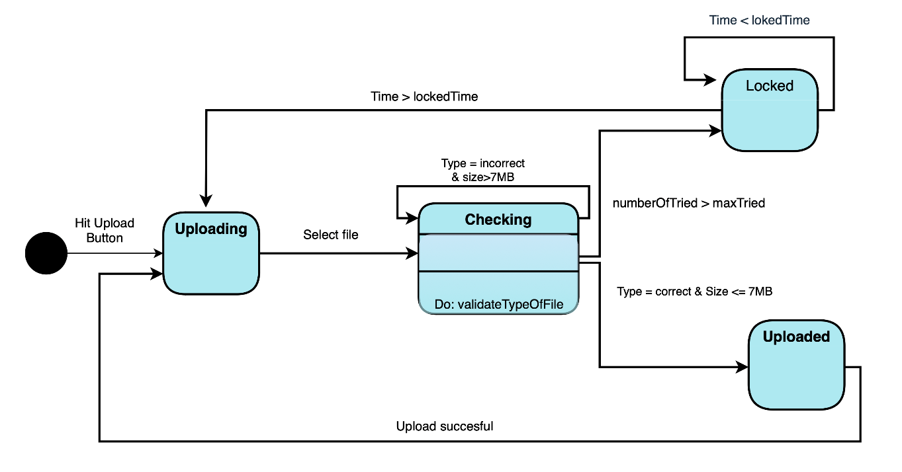

Deliverable #2 (1 Marks) due week 11 for professor review and feedback -Julian
Based on the formal use case description you created in deliverable #2 in Part B, develop a sequence diagrams using Microsoft Visio. Add the sequence diagram to Appendix E of your SRS document.
Refer to unit 07 topic 7.3, chapter 8 & Appendix #1 of your text book for further info about sequence diagrams.

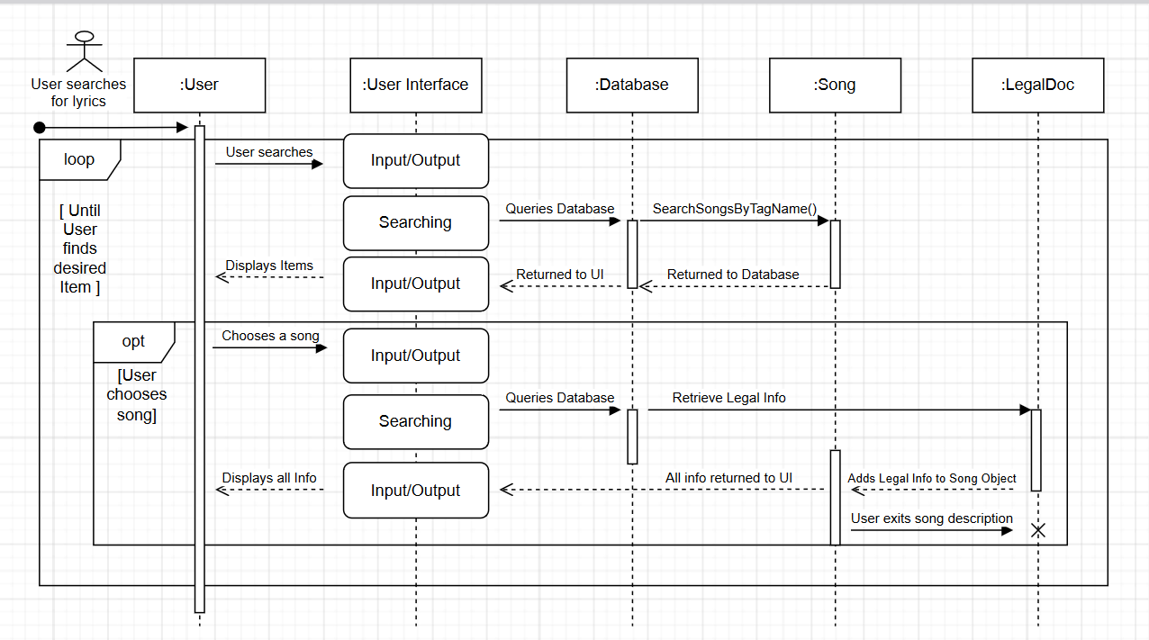

Deliverable #3 (2 mark) due week 11 for professor review and feedback – Joshua D.
Carryout a simple technical review for another teams Part A & Part B project as agreed with your Professor in week#10, review the specification in terms of the below requirements quality attributes:
Attribute | Metric
1. Ambiguity | Number of ambiguous modifiers (e.g., many, large, human-friendly)
2. Completeness | Number of TBA, TBD
3. Understandability | Number of sections/subsections
4. Volatility | Number of changes per requirement  Time (by activity) when change is requested
5. Traceability | Number of requirements not traceable to design/code
6. Model clarity | Number of UML models  Number of descriptive pages per model  Number of UML errors
Write a free text of your findings against each of the six attributes. Discuss with your professor and submit the quality report in the assessment folder week #13 indicating which another team (Project name and Group#4) your team reviewed.

Please see: Group 2 Section 3 - Technical Review of Group 4

Deliverable #4 (2 mark) due week 12 for professor review and feedback-Kuan
Research the “Party Analysis pattern” investigates the possibility of updating your class diagram using this analysis pattern. If possible, add the updated class diagram to Appendix E under class diagrams. Write a small paragraph explaining the value of using this pattern within the context of your project. If it is not possible write a paragraph stating, why this pattern cannot be used in the context of your project.
(Note: The Party analysis pattern was introduced by Martin Fowler in 1996.The pattern is described in his book "Analysis Patterns: Reusable Object Models". The book is available in Centennial library as an e-book and you can access it free of charge. The pattern is explained in detail in Chapter 02, at the time the diagrams were drawn as ERD not UML. Martin followed that by an update with the UML diagrams, search for it on the net.)

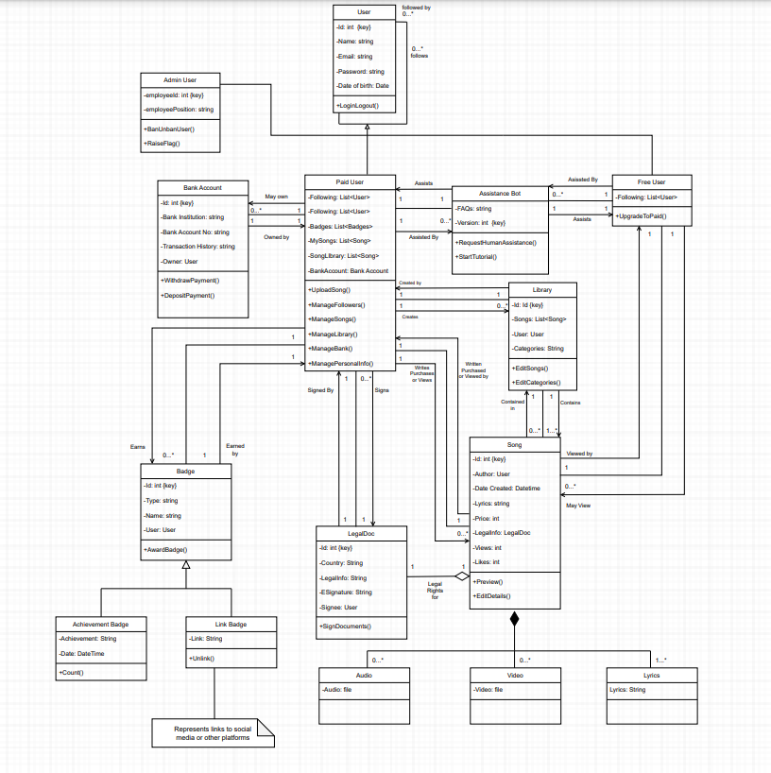

While the party analysis pattern, wouldn’t be ideal for “The Lyricist” project, it would prove to be beneficial to some other aspects of the project, such as actor and user specific functionality. It would be extremely helpful when designing the permissions and functionality of free users, and premium users. With the party analysis pattern, the specific users with premium “Lyricist” paid for, would be able to have more detailed and specific features specified for this specific group of users. As for the free users, while most of their features have been specified in this project already, it could be explored in further depth compared to how it is currently. With the party analysis pattern, the project could also have even further detail to buyer, and seller permissions and functionalities; it would also allow for the entire application to function completely differently, to allow users to use certain features tailored to their own goals with the app. To conclude, the party analysis pattern would be beneficial with specific parties/ groups’ of users but would most likely change the entirety of the application and how it’s supposed to work.

Deliverable #5 (3 mark) due week 13 as per your professor guideline-Hoang
Prepare a power point presentation, using the template posted on the course shell, to be presented end of term.
The template for the final project presentation is available at the following link: Sample Presentation.

